**Project Documentation: DevNet**

**Project Overview:**

DevNet is a full-stack social networking platform for developers to connect, share knowledge, post updates, and showcase professional profiles. Built with the MERN stack (MongoDB, Express, React, Node.js) and Redux for state management, it supports authentication, profile management, and social interactions through posts and comments.

**Key Features**

**User Authentication:**

1. Signup/Login with JWT-based authentication
2. Secure password hashing with bcryptjs

**Developer Profiles:**

1. Create and edit personal developer profiles
2. Add experience, education, and skills
3. View other developers’ profiles

**Posts & Interaction**

1. Create, edit, and delete posts
2. Comment on posts
3. View all posts or personal posts

**Private Routes**

1. Certain routes are accessible only to authenticated users using PrivateRoute component

**State Management with Redux**

1. Centralized application state for user, profiles, posts, and alerts
2. Handles asynchronous API calls with redux-thunk
3. Alerts & Notifications
4. Displays real-time alerts for success or error actions

**Responsive Frontend**

1. Built with React and React Router v7 for SPA experience

**Tech Stack**

* **Frontend:** React, Redux, React Router, Axios
* **Backend:** Node.js, Express, MongoDB, Mongoose
* **State Management:** Redux + Redux Thunk
* **Authentication:** JWT, bcryptjs
* **File Upload:** Cloudinary, multer
* **Dev Tools:** Nodemon, Concurrently, ESLint

**Running the Project**

* Clone the repository
* Install dependencies:
* npm install # backend
* npm install --prefix client # frontend
* Start development server:
* npm run dev
* Visit http://localhost:3000 to view the application

**API Endpoints**

* /api/user → User registration
* /api/auth → Login & authentication
* /api/profile → CRUD for developer profiles
* /api/post → CRUD for posts

**Frontend :**

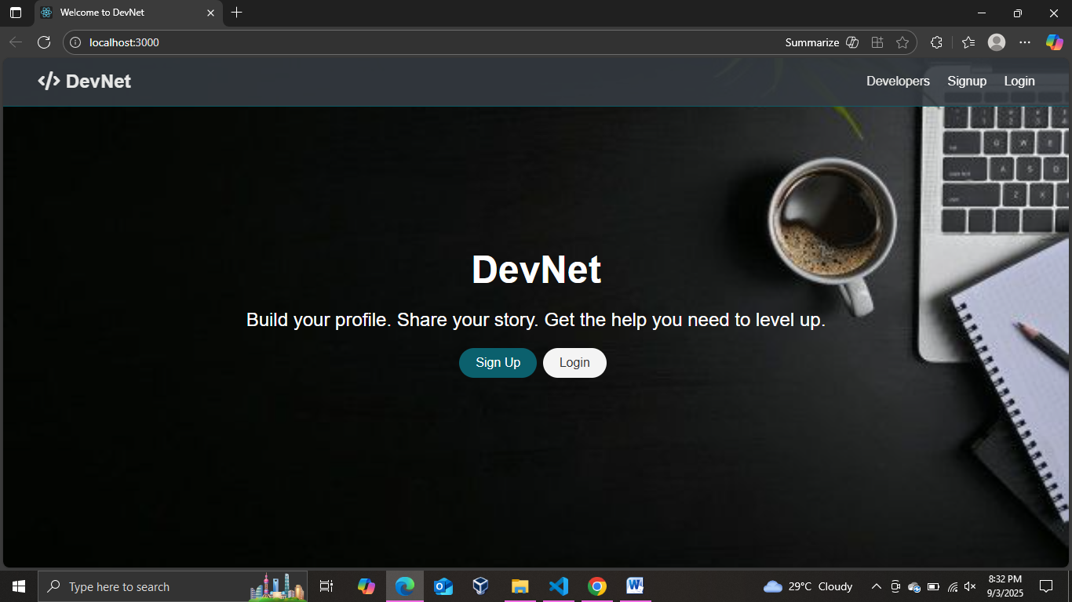

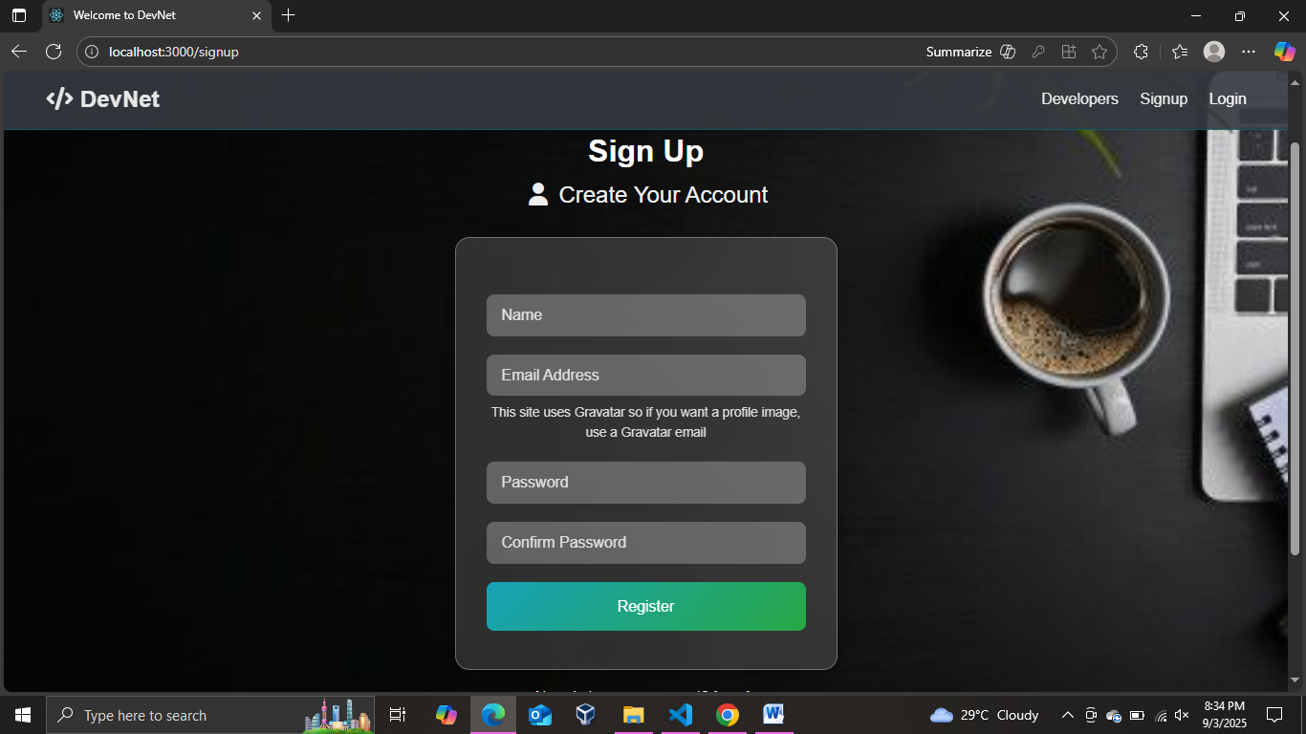

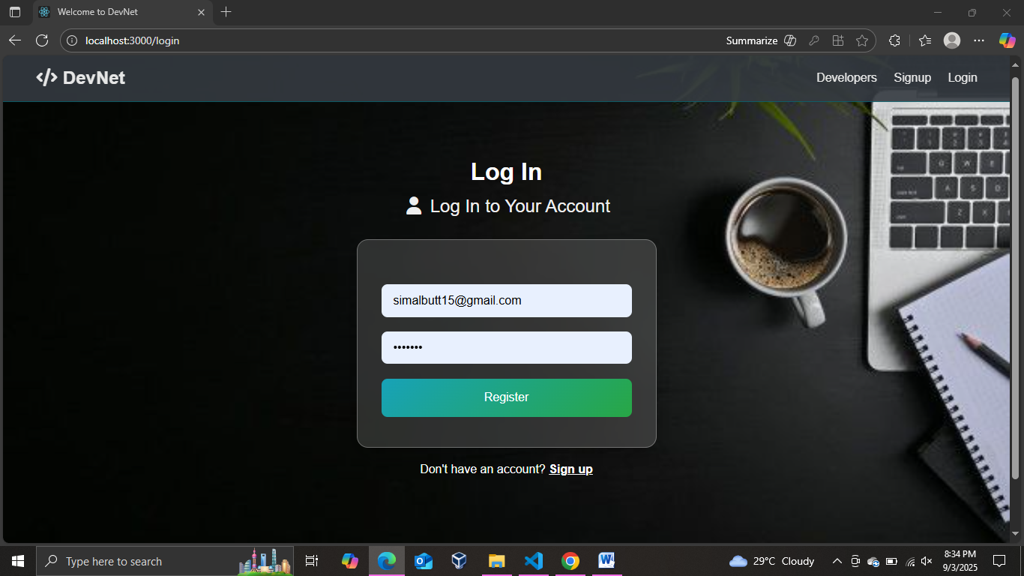

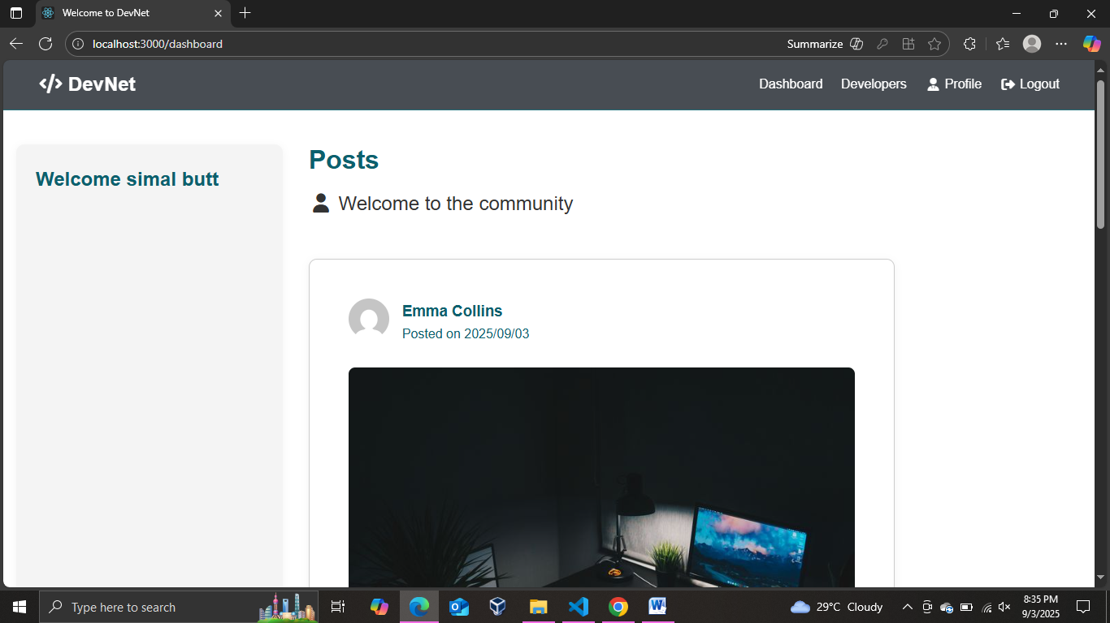

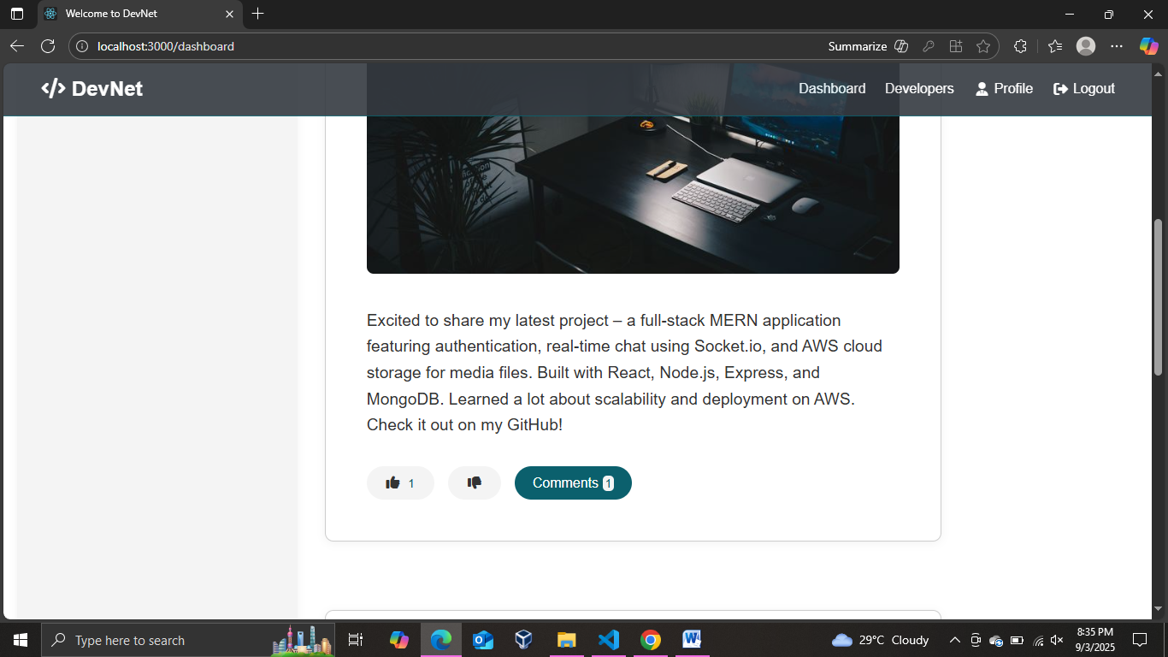

Comment

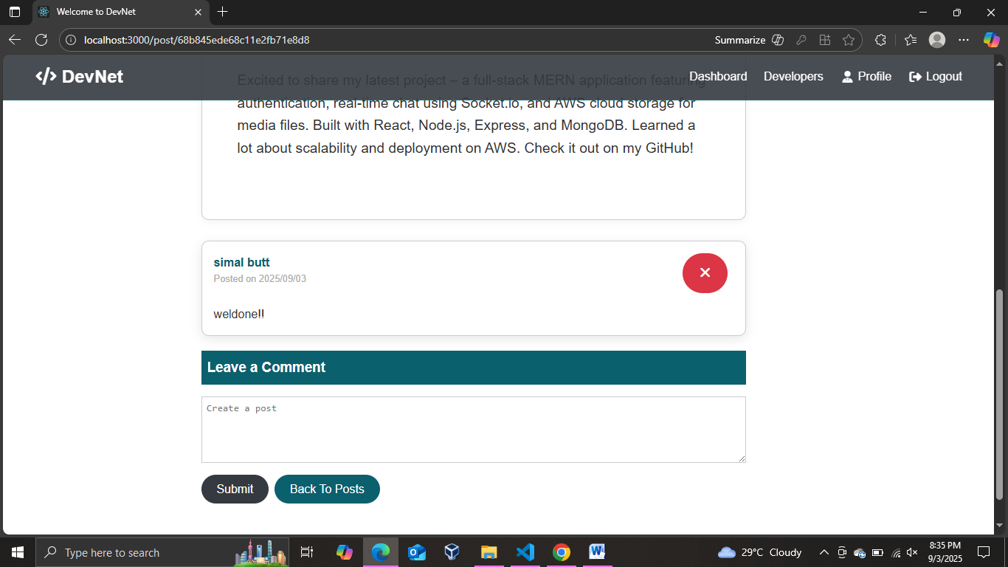

Profile

